Safety
This chapter details the prerequisites and measures for safe opera‐ tion.

Purpose of safety information
Safety information warns of hazards that could lead to bodily injury and damage to property. Always observe and follow safety instruc‐ tions to prevent accidents and injuries from occurring.

The following signal words indicate the category of the hazard and the extent of the danger.

DANGER!
This signal word indicates a direct risk leading to death or severe injury.
WARNING!
This signal word indicates a potential risk that could lead to death or severe injury.
CAUTION!
This signal word indicates a potential risk that could lead to slight or minor injury.
NOTICE!
This signal word indicates a potentially damaging sit‐ uation that could lead to damage to the machine or objects in its vicinity.

Intended use
The machine is intended for the following applications only:
- Use in the food and beverage industries
- Packing containers into disposable and reusable packs. This entails the following processes:
  - Packs move on the pack conveyor into the packing zone.
  - Containers move on the container table in lanes to the stop.
  - The gripper head moves over the container table and packs the containers.
  - The gripper head moves with the containers over the pack conveyor into the packing zone and places the containers in the packs.
  - The full packs are moved along on the pack conveyor.

Use is only considered to be intended use if the operator observes the following points:
- Use as described in the operating instructions
- Use within the limits specified in the Technical Data
- All activities are carried out only by qualified and trained personnel
- Keep persons who are not working on the machine at a safe distance from hazardous and operating areas
- Use of spare and wear parts that comply with original part specifi‐ cations
- Replacement of wear parts within the specified intervals
- Only use the remote access function for rectifying errors and mal‐ functions
- Only carry out remote access via secured network connections

Reasonably foreseeable misuse
KHS will not be held liable for damage resulting from misuse of the machine.
The following are considered misuse:
- Any use above and beyond intended use
- Alterations or modifications without the knowledge and consent of KHS are considered not proper use
- Circumventing or removing protective equipment and safety measures
- Remote access in a different operating mode than Teleservice

- Processing other processing material
- Conveying other processing material, especially from living beings

- Use of the lifting frame for lifting loads
- Connecting USB peripheral devices to the operator console

Obligations of the operator
The operator undertakes to implement measures arising from content in the technical documentation. This includes in particular:
- Compliance with laws and regulations currently applicable at the site.
- Clearly marking hazardous areas.
- Training and instructing personnel.
- Providing personal protective equipment.
- Enforcing prohibitions and mandatory requirements.
- Ensuring devices to secure the shut-off elements are fitted.
- Ensuring signs warning against uncontrolled reactivation are pro‐ vided.

Personnel requirements
Personnel who carry out operating and maintenance activities are subject to strict requirements.
These operating instructions assign activities to the following per‐ sonnel:
Personnel:  Operating personnel
- Maintenance personnel
- Laboratory personnel
- KHS personnel
- Remote access personnel

WARNING!
Personnel who do not meet the requirements
Danger of injury when carrying out operating and main‐ tenance activities.
This could result in death or serious injury.
– Activities may only be undertaken by personnel assigned to the tasks and meeting the require‐ ments.

Only persons who meet the following requirements are authorized as personnel:

- They have reached the statutory minimum age at the installation site.
- They are neither temporarily nor permanently impaired in terms of the following capabilities:
  - Thinking and acting
  - Seeing
  - Hearing
  - Reacting
  - Moving
  - Lifting and carrying
- They meet the legal health requirements applicable at the installa‐ tion site in relation to the goods to be processed and the products to be manufactured.
The following capabilities, knowledge and skills are also required: Essential skills
- Average intellectual capacity
- Average spatial awareness
- Average hand-eye coordination
- Manual dexterity
- Technical understanding
- Understanding of verbal instructions
- Understanding of written instructions Basic knowledge and skills:
- Hydraulics
- Quality testing, quality assurance
- Servicing, repairs and maintenance
Machine-related capabilities, knowledge and skills:
- Functional principle of the machine and its systems
- Operating method and technical specifications for the machine and its systems
- Operating controls for the machine
- Control program
- Safety instructions
- Basic hygiene regulations

KHS personnel
KHS personnel are specially trained and authorized by KHS to under‐ take the activities.

KHS service personnel
KHS service personnel are KHS personnel who have been specially trained to undertake the activities.

Laboratory personnel
In addition to the general requirements, laboratory personnel must also meet the following requirements:
Essential skills
- Average abstract and logical reasoning skills
- Average mathematical skills
- Good observational skills
- Sustained attention when monitoring processes
- Manual skills
- Dexterity
- Planning and organizational skills
- Numeracy skills
Basic knowledge and skills:
- Intermediate level of education
- Vocational training in food technology or equivalent vocational experience (proof required) recognized at the installation site
- At least one year's vocational experience in the beverage and packaging industry
- Microbiological testing
- Chemical, biochemical, microbiological, and technical testing and measurement procedures
- Laboratory work, laboratory procedures
- Food hygiene
- Food testing
- Sampling
- Quality testing and assurance
- Documentation
- Health passport/certificate pursuant to §§ 42 and 43 of the German Protection Against Infection Act (IfSG)
- Laboratory control software
- Food chemistry
- Food legislation
- Food technology
- Microbiology
- Recipes
Machine-related capabilities, knowledge and skills:
- Training and instruction on the area of application specified for the intended use
- Training and instruction on safety instructions and hygiene regula‐ tions

Maintenance personnel
In addition to the general requirements and the requirements that apply to operating personnel, maintenance personnel must also meet the following requirements:

General capabilities:
- Average abstract and logical reasoning skills
- Average mathematical skills
- Good observational skills
- Manual skills
- Dexterity
- Planning and organizational skills
- Numeracy skills
- Oral communication skills Basic knowledge and skills:
- Intermediate level of education
- Vocational training recognized at the installation site and relevant to the performance of servicing and maintenance activities or equivalent vocational experience (proof required)
- Electrical engineering (electronics, electromechanics, electrical installation, mechatronics)
- Automation engineering (hardware and software installation, IT and computer technology, programming, PLC technology and pro‐ gramming)
- Microelectronics (bus systems, microcomputers and microproces‐ sors)
- Production planning
- Hybrid control systems
- Measurement and control technology
- Microelectronics (microcomputer and microprocessor technology)
- Pneumatics
- Test bay operations
- Robotics and handling technology
Machine-related capabilities, knowledge and skills:
- Training and instruction on maintenance and type changes
- Training and instruction on safety instructions and hygiene regula‐ tions
- Special training and instruction on servicing and maintenance activities

Operating personnel
In addition to the general requirements, operating personnel must also meet further requirements:
General capabilities:
- Sustained attention when monitoring processes
- Adaptability

Basic knowledge and skills:
- Standard level of education
- Vocational training or equivalent vocational experience (proof required) recognized at the installation site and relevant to the required activities
- At least one year's vocational experience in the beverage and packaging industry
- Knowledge of manufacturing technology
- Knowledge of machine control and operation
- Knowledge of machine setup
- Knowledge of pneumatics
Machine-related capabilities, knowledge and skills:
- Training and instruction on the area of application and method of operation specified for the intended use
- Training and instruction on safety instructions and hygiene regula‐ tions

Remote access personnel
Besides the general requirements and requirements that apply for maintenance personnel, remote access personnel must also meet the following requirements:
Component-related capabilities, knowledge, and skills:
- Training and instruction by KHS in the requirements and use of remote access
- Service technician or Maintenance personnel user role for identifi‐ cation on the operator console

Protective equipment
Persons remaining or working in the vicinity of hazardous and oper‐ ating areas are required to wear general or special personal protec‐ tive equipment.
WARNING!
If personal protective equipment is not available or not worn
unprotected body parts may be injured. This can lead to severe or even fatal injury.
– Wear the prescribed personal protective equip‐ ment.
General personal protective equipment includes:
- Work clothes
- Steel toe-cap safety shoes with non-slip soles
- Hearing protection suitable for the noise level
The operating instructions makes explicit reference to special-pur‐ pose personal protective equipment if this equipment is required for the task at hand.

Protective equipment against detergents being used
Required personal protective equipment: “see the specifications pro‐ vided by the detergent manufacturer.”

Hazardous areas and identification of these areas
Safety signs described below are attached to the machine. They refer to the immediate environment in which they are attached and are intended to protect personnel.
WARNING!
Removed or illegible marking of hazardous areas If warning signs are removed or rendered illegible,
hazardous areas will not be recognized, mandatory rules will be ignored, and prohibitory rules will not be observed. This could result in death or serious injury.
- Never remove warning signs.
- Replace lost, removed, or damaged warning signs immediately.
- Replace or clean illegible warning signs immedi‐ ately.

    - Warning signs Warning — suspended loads.


Warning — hot surface.

Warning: electrical voltage.



Warning: laser beam.


Warning — risk of hand injuries.


    - Mandatory signs Wear eye protection.

Disconnect the power supply before carrying out maintenance or repairs.


Use a safety harness.

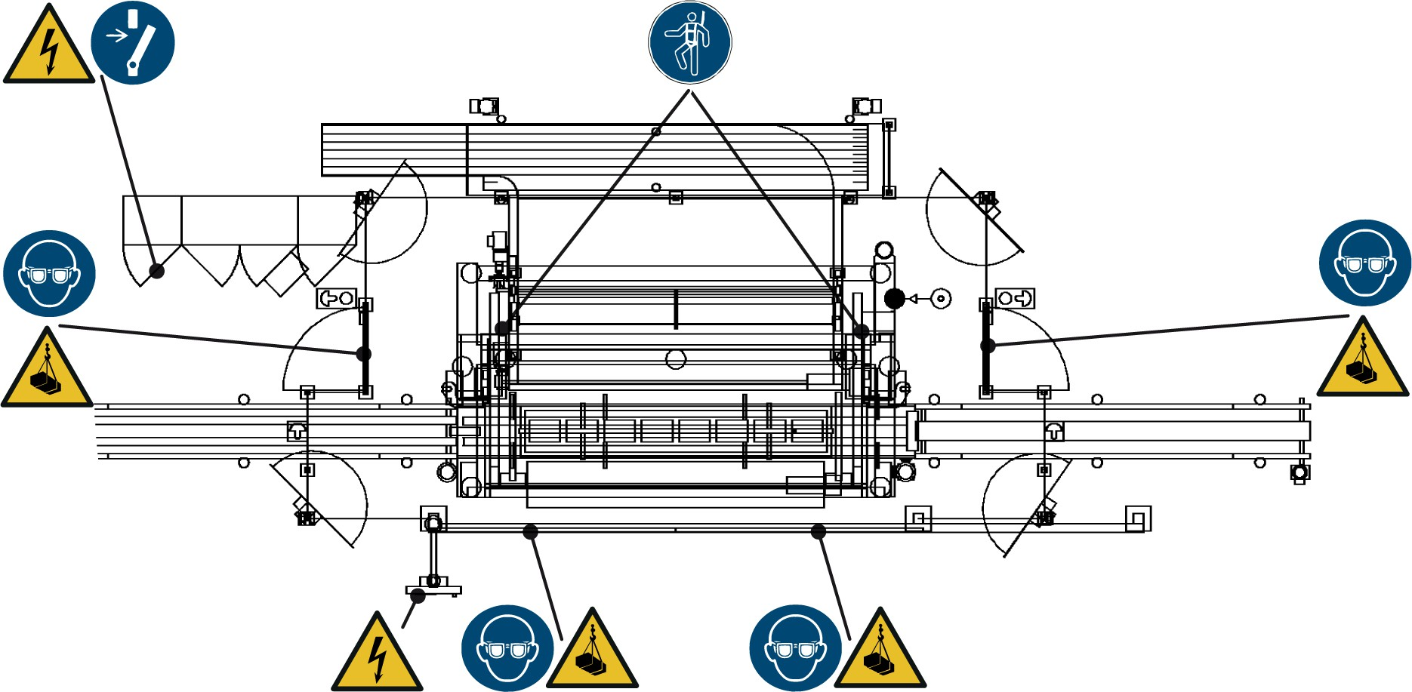
    - Installation location of signs Overview

Figure 2: Installation location of signs

Hazardous area | Labeling | Location
Drives |  | Motor housing
Laser light barrier |  | Laser light barrier housing
Lubricant reservoir of the central lubri‐ cation system |  | Lubricant reservoir housing

Safety equipment
The following safety equipment is installed:
- Housing
- Emergency stop switch
- Fall arrester
- Safety door
- Protection shields
- Depressurization system
- Concave mirrors

DANGER!
Manipulating safety equipment
Manipulating safety equipment poses a danger to life. This could lead to severe or even fatal injury.
- Do not alter the function or position of the safety equipment with structural measures.
- Only operate the machine if the safety equipment is functioning properly.
- Do not remove the safety equipment during opera‐ tion.
- Do not circumvent the safety equipment.

Housing
The housing is a device for personal protection.
The housing surrounds the machine area in which there could be a risk to people. The housing prevents the machine from being
accessed by an unintended route. The machine must not be operated without housing that is in perfect technical condition.
The area within the housing forms the secured area of the machine. The access openings in the machine housing are secured by means of mechanical and electrical locks.
For information on function checks, see chapter “Servicing”, section

“Maintenance” .
Location: The housing surrounds the secured area of the machine, see section “Installation locations for the safety equipment” .

Emergency stop switch
Emergency stop switches are safety devices designed for the protec‐ tion of people.
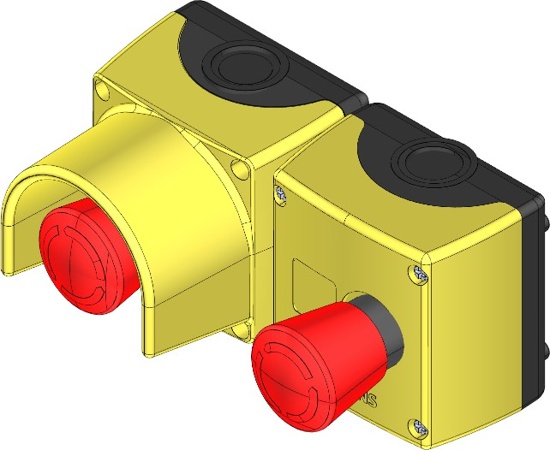

Figure 3: Examples of emergency stop switches

When the emergency stop switch is actuated, all subsections of the machine stop immediately. It is not possible to restart the machine while the emergency stop switch is actuated.
For information on emergency stop switch function checks, see chapter “Servicing”, section “Maintenance” .
For information on the position of the emergency stop switch, see chapter “Safety”.

Fall guard
Fall-guards are devices for protecting people.

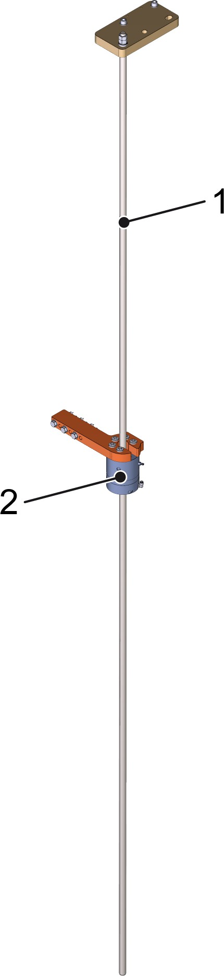

Figure 4: Fall-guard
- Guide rod
- Clamping element
The fall-guard prevents the cross conveyor (entire) from falling.
The guide rod is attached to the frame and guides the clamping element. The clamping element is attached to the cross conveyor (complete).
The clamping element opens when sufficient pressure is applied to the maintenance unit. A drop in pressure triggers the fall-guard. The clamping element closes.
The fall arrester is triggered for the following reasons:

- A safety device interrupts the compressed air supply.
- The supply pressure drops below the minimum pressure.
- Damage has occurred.
For information on fall arrester function checks, see chapter “Serv‐ icing”, section “Maintenance” .
For information on the position of the fall arrester, see chapter

“Safety” .

Safety door
Safety doors are devices for protecting people.
A safety door is the only permissible means of entering the safety area. The safety doors are monitored by means of a door switch. The door switch triggers an emergency machine stop if a safety door is opened in production mode.
See chapter “Operation”, section “Safety equipment” for function information.
For details of the installation location, see chapter “Safety” , section

“Position of safety equipment”.

Protection shield
Protection shields are used for personal protection.
Protection shields are located in various locations on the machine where they perform different tasks. For example, some of these tasks and locations include:
- Voltage conducting parts are mechanically encapsulated and iso‐ lated for protection against electrical shock and damage.
- Pressure conducting lines are mechanically encapsulated for pro‐ tection against damage.
- Protection shields over brake resistors and on motors prevent contact with hot surfaces.
- Protection shields protect moving machine components from inter‐ vention or deadlock.
- Protection shields are built in to protect against damage or dis‐ placement of the sensors.

Depressurization system
The depressurization system protects personnel.
The depressurization system interrupts the compressed air supply to the assemblies when an emergency stop has been triggered.

Automatic depressurization only occurs downstream of the pressure reducer, not on the line upstream of the pressure reducer.
Not all components are depressurized. The packing cups on the gripper heads are always the exception on packing machines. They remain pressurized to ensure that no material for processing is allowed to fall.
The depressurization system is part of the maintenance unit.

Concave mirror
Concave mirrors are devices for protecting people.
Blind spots prevent a full inspection of the secured areas for people. Concave mirrors allow such blind spots to be checked.
For information on function checks, see chapter “Servicing”, section

“Maintenance”.
For details of the installation location, see chapter “Safety” , section

“Position of safety equipment”.

    - Installation location of safety equipment
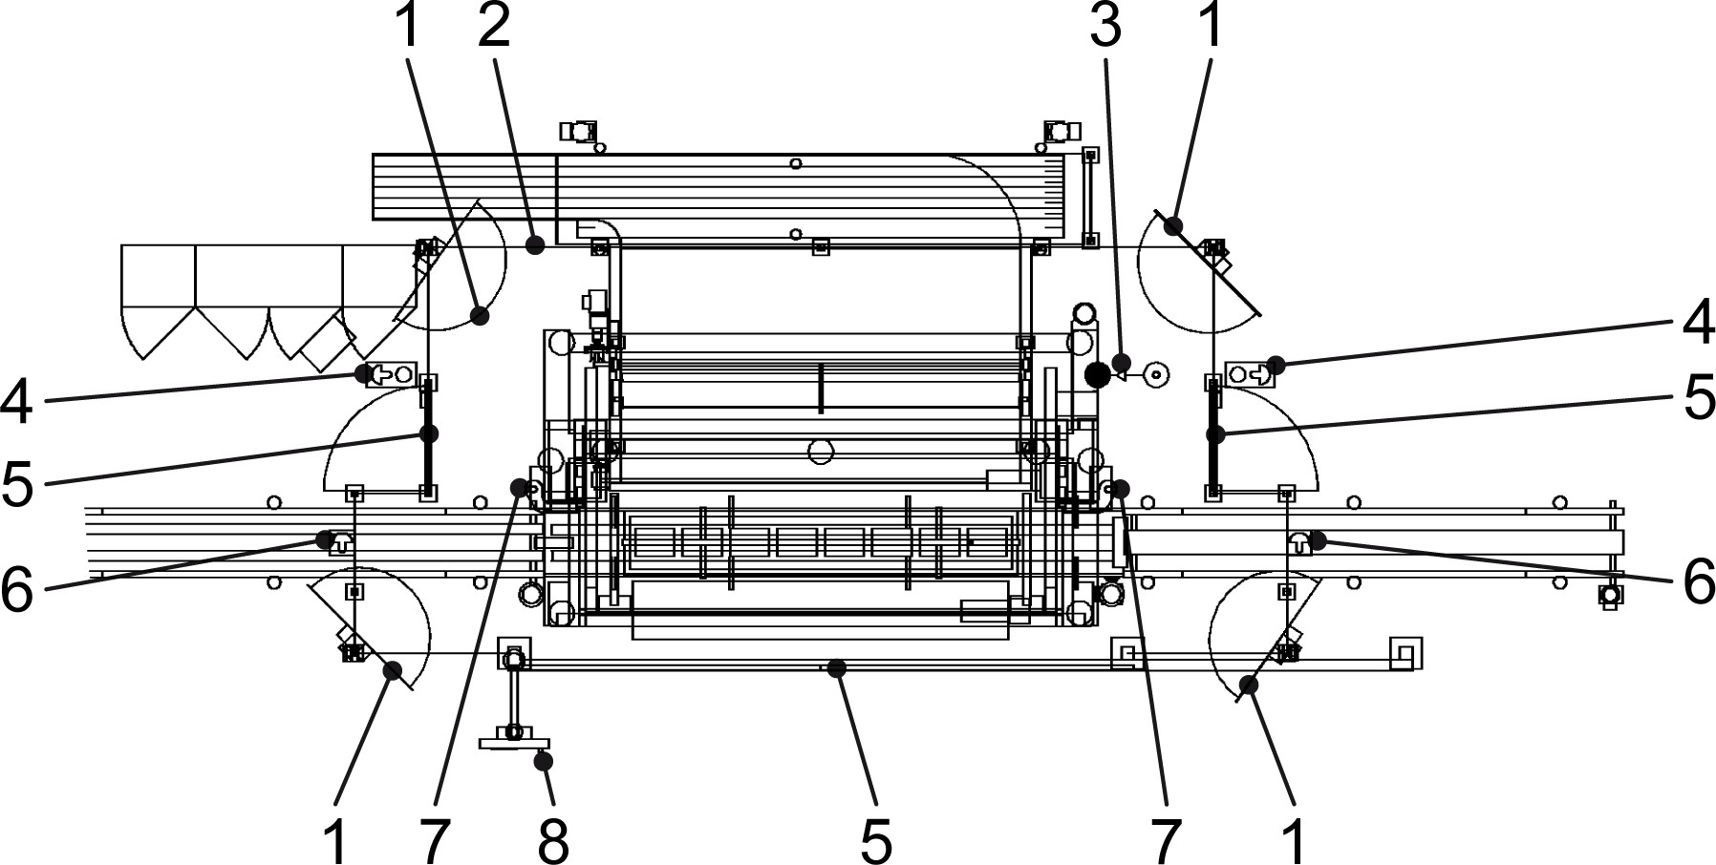

Figure 5: Installation location of safety equipment
- Concave mirror
- Housing
- Depressurization system
- Emergency stop switch on the actuation housing for the safety door
- Safety door

- Emergency stop switch
- Fall guard
- Emergency stop switch on the operator console

Equipment for disconnecting and securing
The following Equipment for isolating and securing is installed:
- Main switch
- Main valve

Main switch
The main switch is designed to protect people.






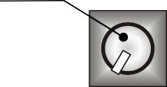
1

Figure 6: Main switch on the switch cabinet
1 Main switch
The main switch interrupts the flow of electricity in the machine and the switch cabinets. The machine cannot be switched back on if the main switch is in the off position.
For details of the energies that this releases from the machine, see the “Servicing” chapter, “Disconnecting and securing” section.
See the “Operation” chapter, “Operating controls” section for infor‐ mation on function.

Main valve
The main valve is designed to protect people.

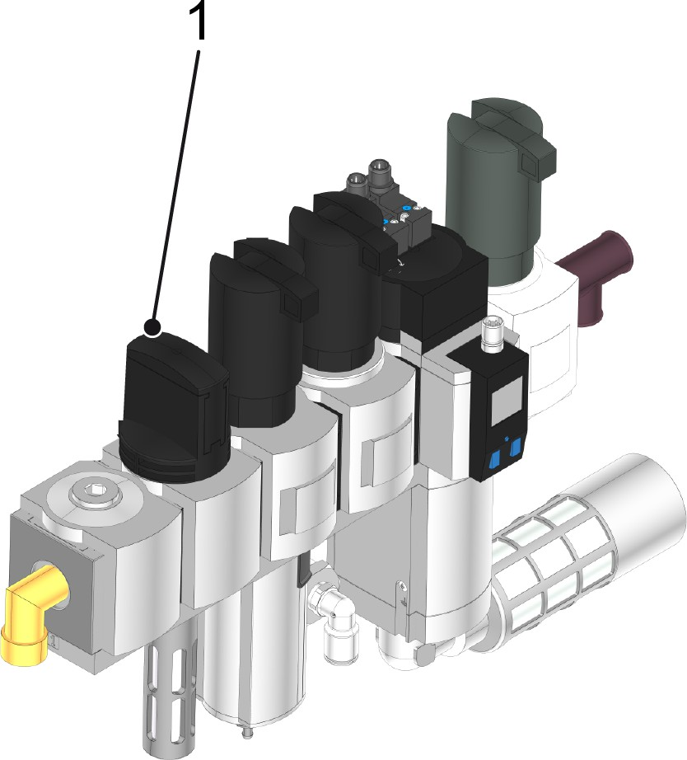

Figure 7: Main valve on the maintenance unit
1 Main valve
The main valve relieves any pneumatic pressures in the machine. The machine cannot be switched back on if the main valve is closed.
For details of the energies in the machine that are dissipated by this process, see chapter “Servicing”, section “Isolating and securing”.
See the “Operation” chapter, “Operating controls” section for infor‐ mation on function.

Installation location of equipment for disconnecting and securing
For information on the installation location of equipment for discon‐ necting and securing, see the chapter “Maintenance”, section “Dis‐ connecting and securing”.

Conduct in hazardous situations and in the event of an accident
Observe the following regulations in order to act properly and safely in hazardous situations and in the event of an accident:
- Local accident prevention regulations
- Local emergency regulations
- Local occupational safety regulations

Conduct in the event of an accident where a person is trapped Initiate emergency measures

- Perform emergency measures in accordance with local regula‐ tions.

Shutting down the machine
- Press the emergency stop switch.
  - Immediate shutdown of the assigned machine.
- Release the emergency stop switch.
- Acknowledge the fault on the console.
- Switch affected areas of the machine to manual mode.
- Release the affected modules in manual mode. Rescuing a person
- Press the emergency stop switch.
- Rescue the injured person and provide first aid in accordance with local regulations.

  - Operating statuses and operating modes The machine has various operating statuses:
- Deenergized machine
- Operating status OFF
- Operating status ON
The operating statuses each provide different safety functions and permit work requiring interventions in hazardous areas.

De-energized machine
The machine is disconnected from the power sources. Residual energy is discharged and the machine is secured against being restarted.
A description of how personnel should activate the machine is pro‐ vided in chapter “Servicing”, section “Disconnecting and securing”.
Personnel:  Maintenance personnel

The machine is designed for the following activities:
- Routine maintenance
- Limited repairs

Operating status OFF
The control voltage is disconnected, the operating controls are shut down. No operating functions (jog, teach etc.) can be performed.

Operating status On
The control voltage is switched on, the operating controls and oper‐ ating functions are activated. Manually-controlled operating functions (jog, teach etc.) can be performed depending on the operating mode.

Automatic operating mode
The machine is connected to the power sources. The safety functions to prevent hazardous machine functions are fully functional.
A description of how to turn on Automatic mode is provided in the
“Operation”chapter, “Preparing for operation” section.
Personnel:  Operating personnel
        - Maintenance personnel
The machine is designed for the following activities:
- Supply with operating materials
- Minor interventions to eliminate faults
- Minor maintenance activities

Setup operating mode
“Setup” operating mode is provided for commissioning the machine once it has been assembled.
This operating mode is reserved for KHS personnel.

Teleservice operating mode
The machine is connected to the power sources. All operating func‐ tions can be carried out. The safety functions to prevent hazardous machine functions are fully functional for each operating function.
A description of how to turn on Teleservice mode is provided in chapter “Faults”, section “Teleservice mode”.
Personnel:  Maintenance personnel
        - Remote access personnel
        - KHS service personnel
The machine is designed for the following activities:
- Remote diagnostics and remote control for fault detection and troubleshooting

Residual risks
In spite of structural and control-related measures, there may be residual risks even if the machine is used as intended.
The following section identifies residual risks that have been deter‐ mined by KHS.
To reduce health risks and avoid dangerous situations, observe the safety instructions listed here, as well as the safety instructions in the other chapters of this manual.
Since 06/27/2018, lead (CAS no. 7439-92-1) has been on the SVHC (Substances of Very High Concern) candidate list under the REACH European regulation. Very small amounts of lead are present in the electrical and electronic components of this machinery. This lead will not be released if the machine is used for its intended purpose. The affected components have been coated with a finish or the lead is contained in an alloy. National regulations for the handling and dis‐ posal of lead and materials containing lead must be observed.

DANGER!
Electrical current
Danger of electric shock from live machine parts. This could cause serious injury or even death.
- Do not touch live parts when the machine is switched on.
- Contact an authorized electrician to work on the electrical equipment.
- Switch off the main switch before working on the electrical equipment.
- Secure the main switch with a padlock.

DANGER!
Entering a secured area at an unintended point
The safety equipment prevents persons from entering or reaching into the area that poses a risk.
If the secured area is accessed at an area that is not permitted, there is risk of fatal injury from components that rotate, move, are not secured or are not safety- monitored.
This could lead to severe or even fatal injury.
- Only enter a secured area at the permitted point.
- Do not climb over, circumvent, remove or manipu‐ late the safety equipment
DANGER!
Falling materials
The materials to be processed may fall at any time. Risk of cuts from flying splinters and materials, or splinters and materials left lying around.
This could lead to severe or even fatal injury. – Shut down the machine and prevent it from
restarting before entering the safety area.
- Allow the machine to run empty before starting work in the machine area.
- Regularly remove residues of material for pro‐ cessing and fragments from the whole machine area.
- Do not remain in the immediate vicinity of materials to be processed.
- Wear safety goggles in the machine area.

WARNING!
Residual risks
Hazards arise when failing to observe the safety instructions for minimizing residual risks.
This could result in death or serious injury.
- Adhere to general legal and company safety regu‐ lations
- Adhere to recognized technical rules for safe and proper practices
- Adhere to all safety instructions contained in the operating manual.
- Adhere to all safety instructions contained in the purchased parts documentation
- Adhere to all accident prevention regulations appli‐ cable in the country of installation
WARNING!
Moving machine parts
Danger of injury and being pulled into the machine by moving parts. Risk of crushing and lacerations.
This could result in death or serious injury.
- Before starting, ensure that no one is in the haz‐ ardous area.
- Do not reach into moving machine parts during operation.
- Maintain a safe distance from moving parts during operation.
- Only perform repairs, maintenance work, cleaning, and disassembly when the machine is discon‐ nected from the mains.

WARNING!
Residual energy when the machine is switched off
Even when the machine is switched off, there is danger of injury due to residual energy.
This could cause severe and even fatal injury.
If there are faults, components do not always return to their final position. As a result, components con‐ tain residual energy in the form of potential energy. When the fault is rectified, the residual energy can be released by the components moving uncontrollably.
– Secure and de-energize the machine before car‐ rying out any work on the machine.
CAUTION!
Laser radiation
When working on machine components that are switched on, there is a risk of injury from laser radia‐ tion.
Looking into the beam path for an extended period can damage the retina of the eye.
This could result in slight or minor injury.
- Never look directly into the beam path.
- Do not direct the laser beam at people.
- Wear protective goggles to protect against laser radiation.
- When assembling and aligning, be aware of the reflection of the laser beam by reflective surfaces.
CAUTION!
Sharp edges on material for processing and waste from material for processing
Manual work involving sharp edges may lead to cuts. This could cause slight or minor injury.
– Wear protective gloves when carrying out any work on the material for processing.

CAUTION!
Hot surface on the motor Burning risk on hot surface.
This could result in slight or minor injury.
- Do not touch the motor.
- Wear protective gloves to prevent burns.
- Always bear in mind that the surface cools down slowly.
CAUTION!
Hot surface on the brake resistor Burning risk on hot surface.
This could result in slight or minor injury.
- Do not touch the brake resistor.
- Wear protective gloves to prevent burns.
- Always bear in mind that the surface cools down slowly.
CAUTION!
Machine environment
There is a risk of tripping and slipping if the machine environment is not kept tidy.
This may result in slight or minor injury.
- Always keep ladders, steps, and accesses clean.
- Immediately wipe up spilled liquids, oils, and lubri‐ cants and thoroughly remove any residue.
- Do not leave any tools or other objects lying around.

This page is left blank for editorial reasons.

